EXPENSE MONITORING SYSTEM AZURE DATABRICKS STEPS
(WORKSPACE, CLUSTER, CATALOG)

NAME :
BATCH 2 DATA ENGINEER

LOGIN INTO AZURE

SELECT DATABRICKS

CREATE WORKSPACE

CREATE AND REVIEW

LAUCH WORKSPACE

SELECT COMPUTE

CREATE COMPUTE

NAME THE CLUSTER

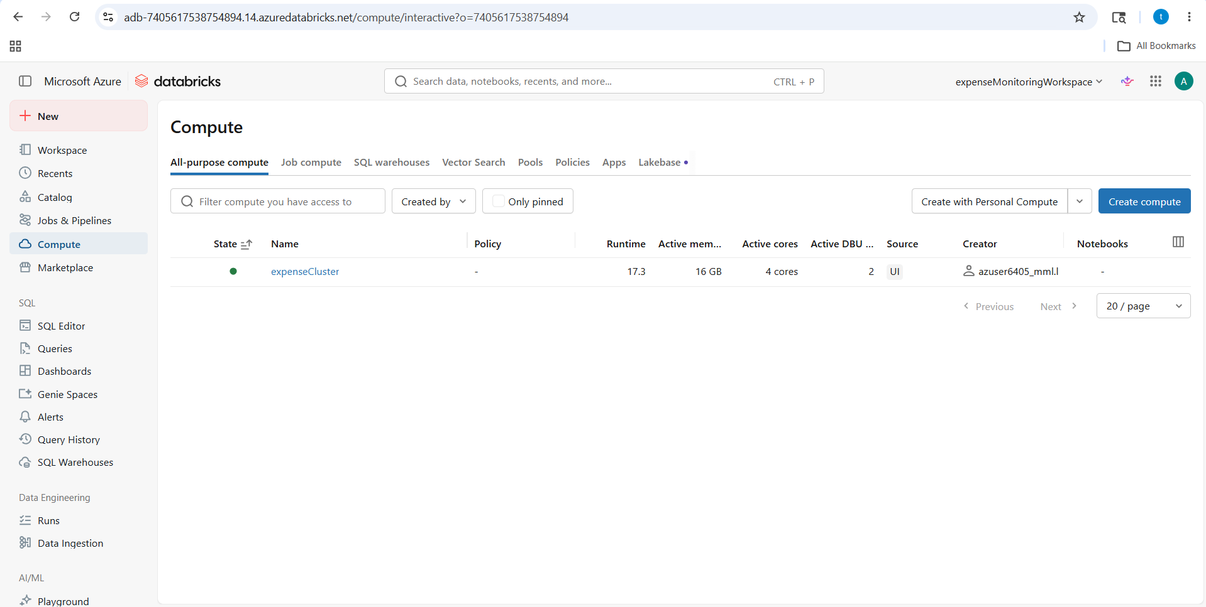

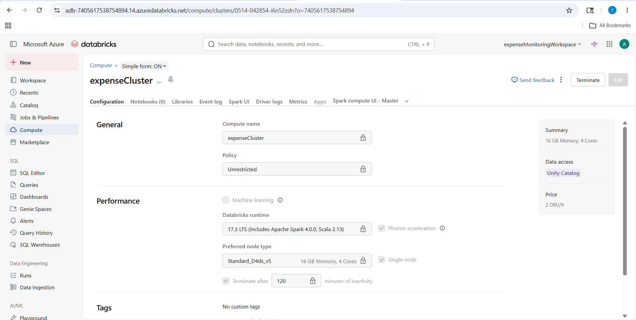

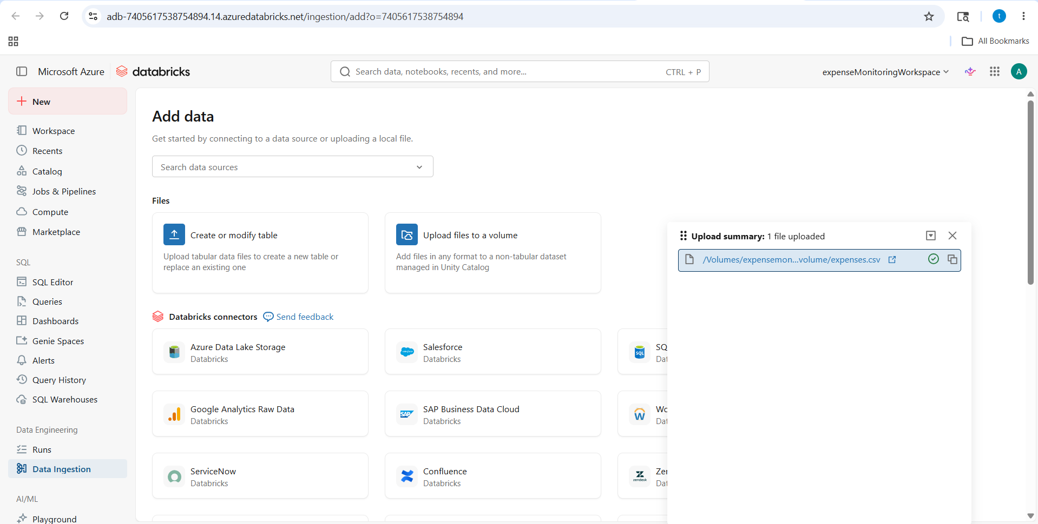

SELECT CATALOG

CREATE A VOLUME

UPLOAD THE CSV FILE (expenses.csv)

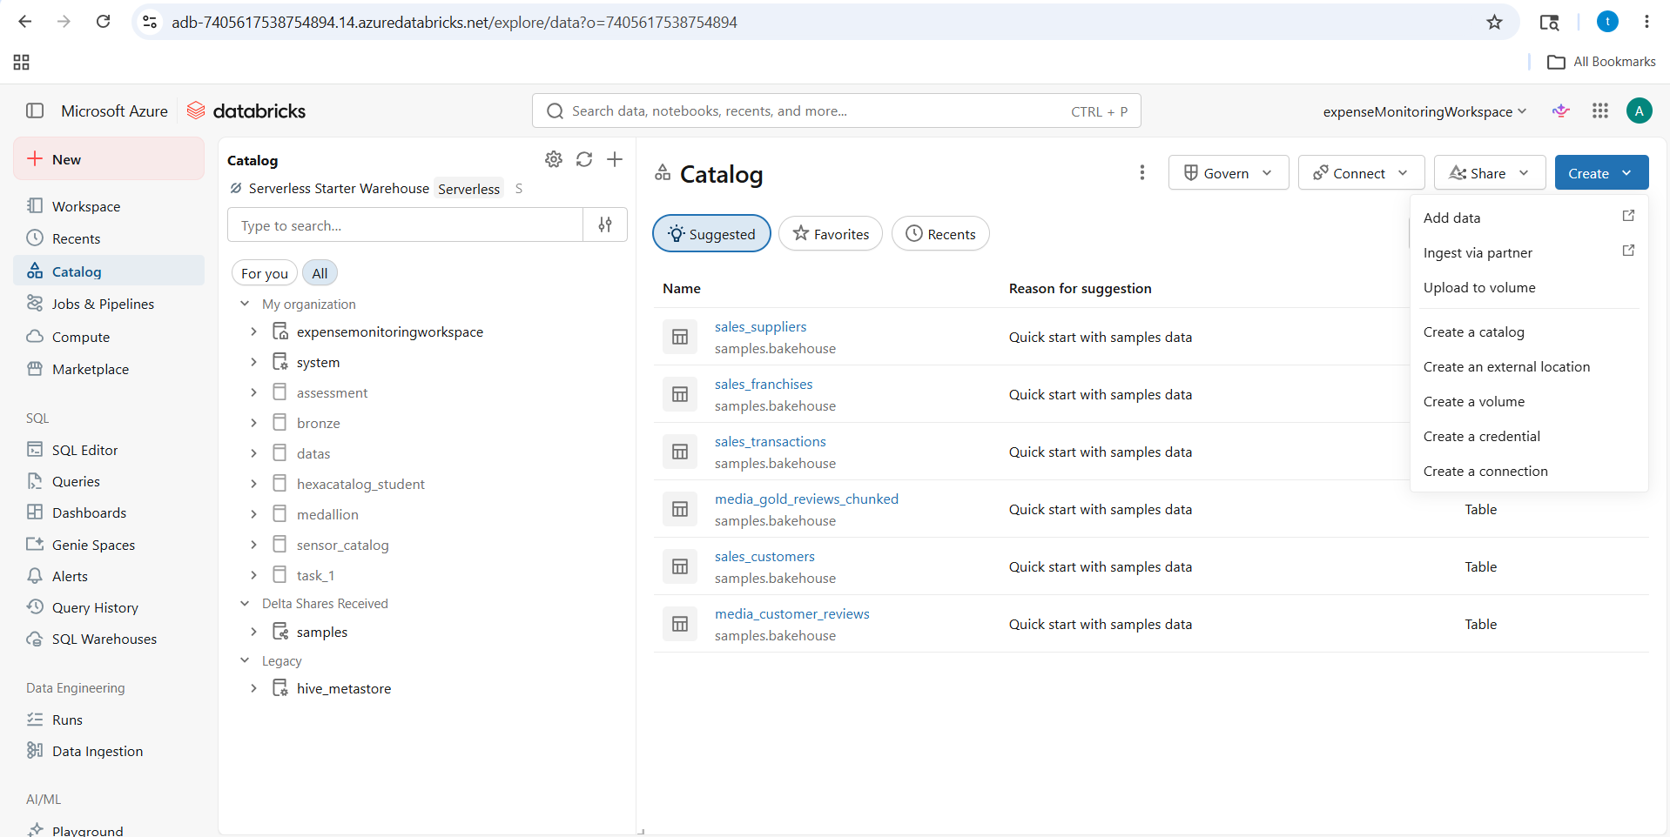

SELECT WORKSPACE

CREATE A NOTEBOOK(ExpenseETL)

EXECUTE THE CODE(change serverless mode to expensecluster)

